Cardio training and core endurance day
Challenging
Duration <45 minutes

Equipment:
Jump Rope
Elevated surface
Open space
Stretch:
Upward dog
Downward dog
Seated reaches

Jump Rope

30 seconds on 15 seconds off
Repeat this process 3 times

Box Jumps or step-ups

Perform 15 reps
Rest for 20 seconds

Repeat this process 3 times

WATER BREAK

Core stability pt. 1 (do twice)

20 lunges
1 minute plank
30 second mountain climbers

Core stability pt. 2 (do three times)

10 burpees
10 bodyweight squats
Russian Twist:
25 Russian twists
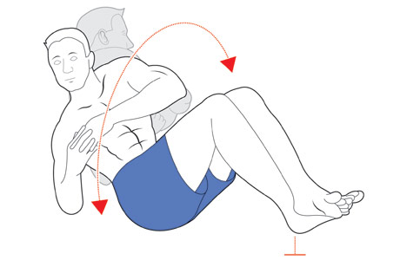
Run for 10+ minutes

Stretch program.
Drink water

