Back
Hardcore
Duration: 1.5 hours

Be in a gym.
Focus on form. Contact Eric for guidelines on muscle movements.
Pace yourself and take breaks.
Drink water throughout the workout.
Be Smart don’t let your ego get in the way of safety.
For Toning and Endurance: High rep low weight
For Size and Strength: Low rep high weight

Bike for 20 minutes

Here are some basic chest exercises, feel free to manipulate the set count in any way or do them like I suggested. Make sure you do the ** workouts because of the particular area of the chest they target.

Perform 5 wide pull-ups between EVERY set

*Bent over rows w/free weight barbbell 3 sets

Bent over back fly 5 sets (light weight)

Lat pull down 5 sets

Shrugs 5 sets

Low row 5 sets

*Lat push down 5 sets

*Dead lifts 5 sets

Stretch !

See next page!

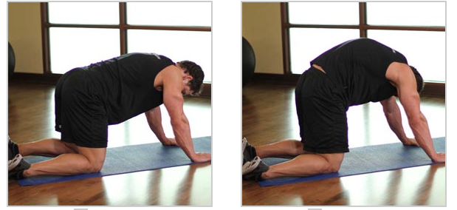
Cat stretch

Middle back
Lower Back

One arm against wall

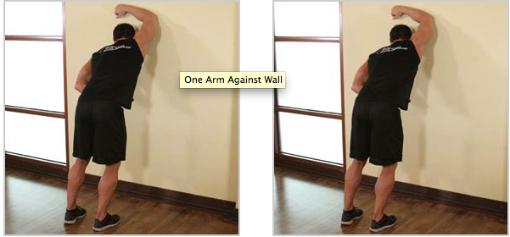

Latissimus Dorsi (lats)

Childs pose

Lower middle and upper back
