Nutrition Guide

Remember: No “one size fits all” method works for nutrition.

These are simply 5 guidelines; follow them to the best of your ability. If you mess up don’t fret, simply acknowledge your mistake and move forward.

Take this guide to the super market and stock up on vegetables. Eating healthy is more than half the battle

THIS IS NOT A DIET. THIS IS A GUIDE FOR EATING FOR LIFE

First Identify your body type: This will be helpful later in the process when your goal comes into play.

- Ectomorphs (Left): High metabolism and higher tolerance to carbohydrates. In general, ectomorphs tend to do better on high carbohydrates, moderate protein and fat. Typically, ectomorphs resemble the build of lean and lanky long-distance runners.
- Mesomorphs: The most balanced of the three, mesomorphs can build muscle and maintain low fat levels. Their body likes a balance of carbs, fat, and protein.
- Endomorphs (right): Endomorphs are reminiscent of powerlifters who have a slower metabolism and tend to hang on to both muscle mass and fat. They do quite well on high fat and lower carbohydrate intake.
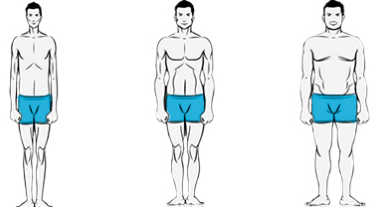

Now lets get started:

First establish what I like to call “your foods?”

Choose 2 foods that you love and cannot go without (food that would otherwise not make the cut) For example my two are Bacon (drenched in oil and fat) and nutella® (also high in fat and sugar)

Enjoy these two foods when an opportunity to have them arises.

Second we have our generic guidelines, do your best to follow them…
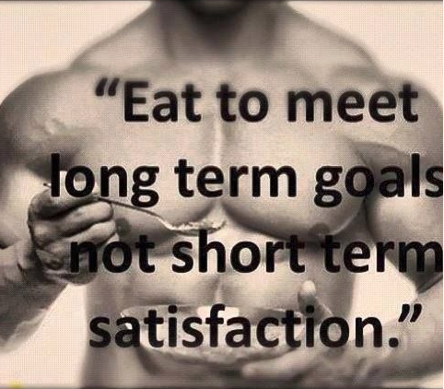
Avoid:
(Keep track of which ones are hard to do)

Carbonated drinks
Excessive amounts of salt or oil in one meal
ANYTHING fried (unless is conflicts with “your foods”
Try not to eat meat from animals more than 3 times a week
Artificial sweeteners (especially Splenda—which is proven to slow down your metabolism)

Aim for:
(Keep track of which ones are hard to do)

Multiple glasses of water a day
3 different types of vegetables a day
More food at breakfast, less food at dinner.
Stop eating when you not hungry anymore, not necessarily full

Third. My advice for eating out of the house…

Have a buddy (that cares about their health) to keep you in check. When you are out with friends and everyone is eating crap agree with your partner “I won’t cheat if you won’t” The biggest reason we eat crap food is because its all around us and everyone eats it, having someone in the same boat as you helps infinite amounts.

Don’t go to a fast food place.

If you are with a bunch of friends AND THEY ABSOLUTELY INSIST you eat at a fast food joint just avoid French fries and stick to just a burger.
Example: you’re all drunk at 4 am and decide McDonalds is just the best option. Resist the urge to get everything, get one burger and eat it slowly savoring every bite. One burger WITHOUT fries won’t kill you and hopefully because you exercised that day your metabolism will tear through it.

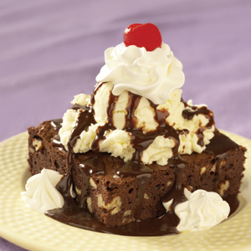
Out to dinner at a normal restaurant: Enjoy it. Order what you order and don’t worry about what’s in it.
**Drink plenty of water though because restaurants tend to put lots of salt in meals.

Hopefully not everyone will order a dessert for himself or herself and only get one for the table. In this situation take one bite. That one bite will taste as good as the first, second, third or even fifth. Take one bite and stop.

(If people do order dessert remind yourself that what you eat in private you wear in public) Unless they have “your food” DO NOT CHANGE “YOUR FOOD”

IMPORTANT: UNLESS IT IS ABSOLUTELY INCREDIBLE IT’S NOT WORTH THE USELESS CALORIES

Four: What to look at when reading nutrition label before putting it into your body.

Many people make the mistake of just looking at the nutrition facts and claiming that because its low in calories it must be ok. This is why we’re fucked. The calories don’t matter: what makes up those calories does.

It is much better to consume 500 calories of vegetables vitalizing sustenance than 100 calories of oil and sugar.

READ THE INGREDIENTS!

Many people don’t know this but the order that the ingredients are in is based on the quantity of that item in the product. For example if the first ingredient is sugar, or a word you can’t pronounce, it probably does not belong in your body! Just take a look at this Oreos® Ingredients list.

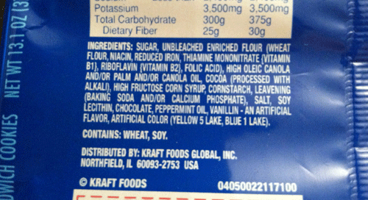
Danger words:
-Enriched
-High Fructose corn syrup
-Dye
-[Color, #]
-Partially hydrogenated soybean oil
-“Artificial…”
-Corn syrup

Remember; don’t be fooled by enticing packaging and pre-conceived notions.

This protein bar would seem like a healthy post workout option:

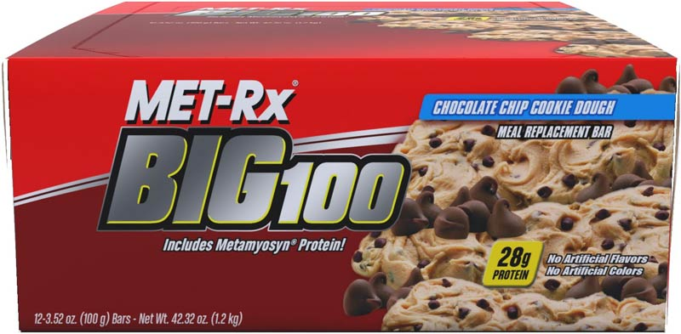

Nutrition facts:
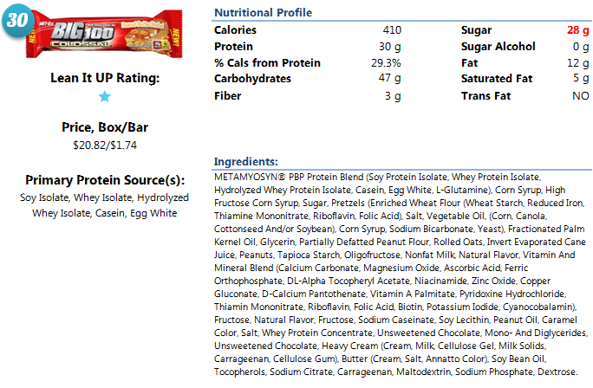
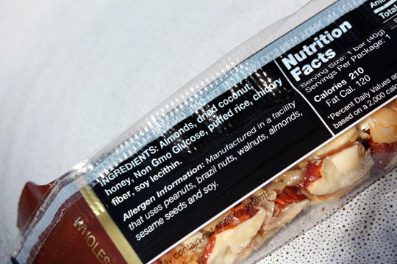
Notice the high dosage of sugar. Sugar is not bad, but High fructose corn syrup is extremely refined and processed synthetic sugar that your body cannot process. Look at all the “danger words” in the first few lines alone.

This is a much better option:
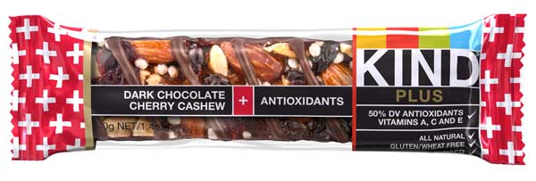

Five Size matters.

- Normal Portions
Over eating is arguably the unhealthiest thing you can do to your digestive system and body. Eat to sustain until the next meal, not for the winter.

- Normal pacing. Slow down, no ones going to take your food away.

Six pre make food.

After a workout your hungry, this is a known fact. Coming home starving may lead to a poor decision like eating a bag of Doritos.

To avoid this simply prepare meals that can be microwave easily before you go and workout.

Want a recipe or good post/pre workout eats?

Here are some suggestions:

•Whole-grain cereal with milk and a banana
•Greek yogurt with fruit and handful of granola
•Poached eggs and whole-wheat toast
•Hummus with whole-wheat pita and vegetables
•Smoothie with whey protein, milk, banana and ice*

- Don’t have whey protein for a shake try this alternative recipe:

In a blender:
Spinach 1 cup Almond milk 1 glass
Greek Yogurt Blueberries ¼ cup
Blackberries ¼ cup dry Oats ¼ cup
Banana 1

Nutrition tips 7-8 depend on your body type and goals…

Seven, follow these few tips if you’re looking to pack on mass (you may consider yourself an ectomorph)

-Get casein protein into your system before bedtime. This protein will thicken in your gut and provide a steady supply of nutrients and amino acids to your muscles through the night to stop muscle catabolism (loosing gains).

Foods with casein protein:

Unsweetened low-fat cottage cheese
one to two ounces of nuts or seeds (almonds, cashews and pistachios)

Eat frequently to keep a constant flow of nutrients into your muscles. Unlike fat, muscle is a metabolically active tissue that constantly needs nutrients to keep growing. Additionally, this prevents ravaged behavior like eating the left over cake in the fridge when you get home. THIS IS NOT A GREEN LIGHT TO POUND PIZZA EAT PHYSIQUE FRIENDLY FOODS:

Chicken (not fried)
Spinach
Salmon
Beans
Oatmeal
Whole grains

Eight, Follow these tips if you’re looking to slim down/cut fat.

Don’t STOP eating carbohydrates, simply take two days a week for “low carb intake”

Never go lower than 50g of carbohydrates.
Variety!

Take in a variety of clean, high-quality food sources such as poultry, beef, pork and fish, grains, legumes, seeds, fruits and vegetables. Try to avoid eating the same thing too often, which begets boredom anyway.

Drink milk!
- Eating plans that consist of several high protein/low carb meals result in an unbalanced pH putting your body into an acidic state, when this happens

If you make a shake or smoothie, be sure to throw chia seeds in. They not only are packed with fiber and essential fatty acids but they will bloat in your stomach and slow the digestive process in order you to help break down carbs and convert them into sugar restricting them from feeding your fat cells.

For more info on anything I have mentioned contact me or check out…

http://www.muscleandfitness.com
http://www.bodybuilding.com

GOOD LUCK!

