Lower Body Training Day
Challenging
Duration: <1 hour

Equipment:

Lightweight Barbell (20-40 lbs recommended)
Heavyweight Barbell (50-80lbs recommended)
Leg Press Machine
Seated hamstring curl or lying hamstring curl machine

For Size and Strength: Low rep High weight
For Definition and Endurance: High rep low weight

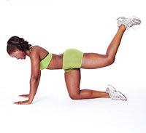
Stretch
-Seated reach stretches
- Horizontal leg swings (ballistic warm up)
- Mule kicks (see picture) both legs
-Upward/downward dog

Warm up X3:

15 lunges without weight
5 dead lifts with lightweight
5 form squats with lightweight

Leg press: 3 sets
1 minute between each set.

Seated hamstring curls 2 sets

Weighted Squat: 3 sets
1:30 between each set

Dead lift: 3 sets
1:30 rest and upward dog between each set

15+ minutes on stairs or bike

Do stretch routine

