Biceps, Triceps and Deltoids
Hardcore
Duration 1.5 hours+

A superset is when you complete a lift during the rest period of that only utilizes a different muscle group.

For example while doing bicep curls I might do triceps extensions during my rest period. This is to keep your blood pumping and hear rate up.

Remember the set counts are completely recommended. You can alter the how you want to fit your needs.

Especially for arms form is crucial. Don’t fight for extra reps if you are going to sacrafice form. It’s not about how much you lift, its HOW you lift it.

Bike or Run (opposite of day before) for 20 minutes

Circuit 1 [X2]

21's w/ barbell
-7 half curls bottom half
-7 half curls top half
-7 full curls

Skull Crushers [10]

Stall Curls (16 reps)
-Do four curls with the left arm while holding a dumbbell and half contraction. After four switch arms so your right arm is curling and your left is stationary. Do this whole thing twice with both arms.

Overhead Tricep Extentions (one dumbbell)

Shoulder Flys 3 sets
-Alternate between out to the sides and out forward to fire different areas of the shoulder (front and middle)

[(10 pull-ups, 15 dips, 20 triceps pushups) X3 sets]

Posterior shoulder roll 3 sets both arms

Tricep pull down (ropes) 4 sets
-Remember to spread hands apart at full extension

Shoulder press 4 sets

Cable rope overhead triceps Extensions 4 sets

Tricep Push down (Bent bar) 4 sets

Reverse bicep curls 3 sets with dumbbell
-Hold the bar from the top and perform curls

Weighted circles with 5lb: 30 seconds on 15 seconds off [X4]

Stretch. See next page

Overhead triceps pull
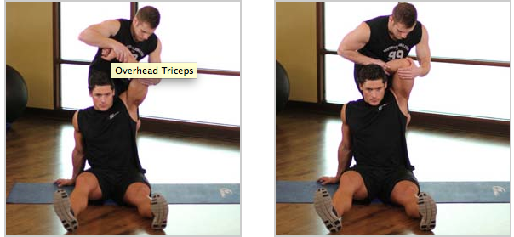

Behind back bicep stretch

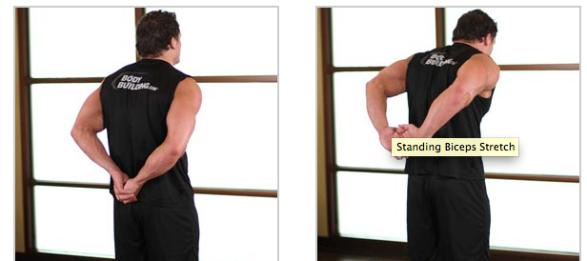

Use foam roller to target specific soar areas.

