10 minutes of stretching
To be done when you wake up and post workouts

Standing Hamstring and Calf Stretch:

- Begin by looping a belt, band, or rope around one foot. While standing, place that foot forward.
- Bend your back leg, while keeping the front one straight. Now raise the toes of your front foot off of the ground and lean forward
- Using the belt pull on the top of the foot to increase the stretch in the calf. Hold for 10-20 seconds and repeat with the other foot.
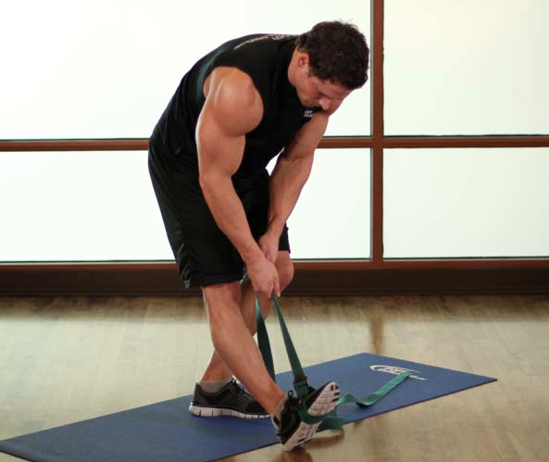

Dancer’s stretch (gluteus):

- Sit up on the floor.
- Cross your right leg over your left, keeping the knee bent. Your left leg is straight and down on the floor.
- Place your left arm on your right leg and your right hand on the floor.
- Rotate your upper body to the right, and hold for 10-20 seconds. Switch sides.
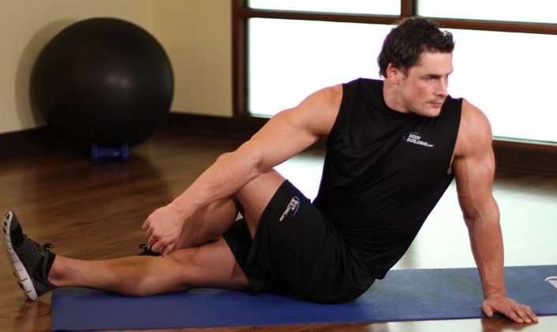

Sit and reach with legs together. Hold for 1 minute

Side leg raises: Both legs
- Stand next to a chair, which you may hold onto as a support. Stand on one leg. This will be your starting position.
- Keeping your leg straight, raise it as far out to the side as possible, and swing it back down, allowing it to cross the opposite leg.
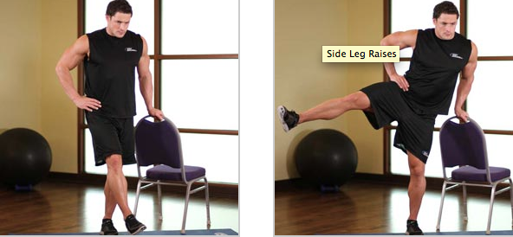
- Repeat this swinging motion 5-10 times, increasing the range of motion as you do so.

1 minute of slow arm circles, switch direction after 30 seconds

Overhead Lat stretch:
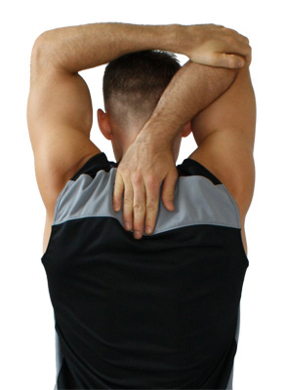
1. Sit upright on the floor with your partner behind you. Raise one arm straight up, and flex the elbow, attempting to touch your hand to your back. This will be your starting position.
- Attempt to pull your upper arm to your side as your other hand holds your elbow preventing you from doing actually doing so.
- After 10-20 seconds, relax the arm and allow your other arm to further stretch the lat by applying gentle pressure to the triceps. Hold for 10-20 seconds, and then switch sides.

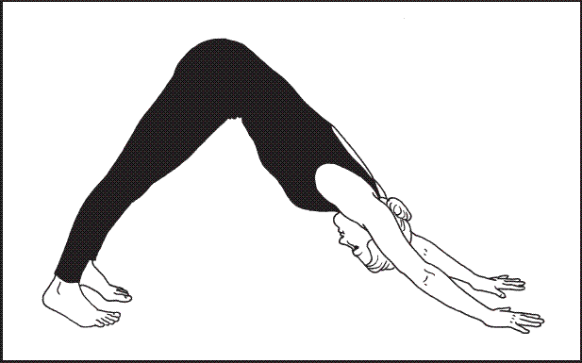
Downward Dog:

1. From Child's Pose, curl your toes under and press up and back into Downward-Facing Dog.
2. Place your hands shoulder-width apart with the wrist creases parallel to the front edge of your mat. Firm and straighten your arms.
3. Keep your feet hip-width apart and the outside edges of your feet parallel to one another.
4. Firm your legs: Lift your kneecaps; press the tops of your thighs up and back; press your heels down.

Upward Dog:
- Lie on your stomach with the tops of your feet on the floor. Place your hands beside your rib cage with fingers spread wide, finger tips below the line of the chest.
- Press into your hands, feeling the ball joints of your fingers (under the knuckles) in contact with the mat. Squeeze your elbows by your side, roll the shoulders onto the back body, and reach out through the top of your head.
- Draw your low belly in towards the spine, and create a slight inward rotation of the thighs, and press the toenails into the mat.
- On an inhale, press into your palms, imagining you are sliding your body along the earth. Lift your torso and hips off the mat, so that it is only the tops of your feet and your palms are in contact with the earth.
- Tuck your chin in slightly, lengthening the top of your neck near the skull, and reach out through the top of your head but keep your gaze down your nose.
- Imagine the back bend coming from your heart centre, sending the sternum forward, while keeping the drawing in of the low belly.
- Breathe comfortably in and out

